

UW Events Prototype

Project Group Members: Alon Levy, Jasmine Losovsky, Brittney Oeur, Vincent Tran, Jocelyn Velazquez

INFO 200 | Section AB| Amy Oguejiofor

Table of Contents

**The Team 2**

Team Members 2

**Problem Statement 3**

**Solutions Considered 4**

Solution 1 4

Solution 2 4

Solution 3 4

Solution 4 5

**Selected Solution 6**

**Solution Description 7**

Product Features 9

Primary Features 9

Secondary Features 10

**Low-Fidelity Wireframing Stage 11**

**Low-Fidelity Wireframes 13**

**Moodboard 20**

**Design Language / Style Guide 21**

Font 21

Colors 22

**High-Fidelity Wireframes 23**

Navigation Bar: 23

Landing Page: 24

Event Listing Page: 25

Event Listing Page + Filter: 26

Individual Event Page: 31

Create Event Page: 32

User Page: 33

My Events Page: 34

Joined Events Page: 35

Bookmarked Events Page: 36

**Interactive Prototype 37**

**References 38**

**Appendix 40**

# The Team

## Team Members

**Alon Levy:** I am a freshman in pre-sciences, attempting to major in Informatics. My skills are basic Java, robotics, and creativity. My responsibilities for the problem statement are writing the conclusion and summarizing my group’s research.

**Jasmine Losovsky:** I am a double degree student in both informatics and business administration. My skills include coding, effective communication, and creativity. My responsibilities for the problem statement are taking part in the research team, researching social media websites, and interviewing students about our topic.

**Jocelyn Velazquez:** I am currently a sophomore in HCDE looking to transfer into INFO. My skills primarily lie within UX/UI principles that focus on human-centered design. I have basic Java knowledge. My part of this team is on campus maps research– I will search for what information is already provided through maps and what can be improved upon.

**Brittney Oeur:** I am a senior majoring in Applied Computing and minoring in Informatics. My skills include knowing C++ (such as algorithms and data structures) and graphic design. I will be focusing on the quality assurance for each group assignment—polishing up assignments, and ensuring that each task is being fulfilled and done correctly.

**Vincent Tran:** I am a second-year student with an intended major in Informatics. I have basic Java programming knowledge and am proficient in communicating ideas as well as questions to initiate discussion. I will be researching official UW websites and forums compiling its aspects toward our orientation of an effective problem statement.

# Problem Statement

The team’s primary focus is to address a challenge within the University of Washington (UW) student community. The problem that will be investigated and addressed is the inadequate and disorganized information regarding the scheduling and locations of various events taking place on the UW campus. This includes club meetings, career fair events, and any other university-related gatherings.

This problem must be addressed because the current state of event information is convoluted and difficult to navigate. The confusion that this causes may lead to frustration and discouragement among students who wish to participate in these events.

Solving this problem would help UW students positively because they would be less confused and foster greater enthusiasm for event participation. This in turn can help enhance their UW experience. Attending these events can help students make friends, but also provides an opportunity to acquire new knowledge of something they may be interested in. This positive impact on students' social connections and educational experiences underscores the importance of addressing the issue.

**Critical Issues to be Addressed:**

* **Lack of centralized information:** Events across different departments and clubs are not effectively centralized or accessible in one location, making it challenging for students to find comprehensive information.
* **Information fragmentation:** The scheduling and location details of various events are scattered across multiple platforms, leading to confusion and difficulty in tracking and accessing relevant event details.
* **Accessibility issues:** The current system may not cater to all students' needs, potentially excluding those who rely on specific types of communication or platforms for event information.
* **Impact on student engagement:** Inadequate event information may result in reduced participation, affecting students' ability to engage with the campus community, find new opportunities, and expand their social and academic networks.

# Solutions Considered

## Solution 1

The idea of developing a mobile application dedicated to UW event organization is the first solution devised. This will include features that are suggested by students. These include lots of filters and a user-based system where students can log in and include information about themselves. The primary advantage of an application is its convenience. It will offer users an easily accessible, simple, and responsive platform for event information. A drawback is its limited accessibility to computers, excluding students who prefer using computers or who do not have a smartphone. Another limitation is that all clubs and organizations would have to download the application.

## Solution 2

A network of social media accounts created to organize and display UW events to students is the second considered solution. This idea is heavily based on suggestions from an interview with a primary stakeholder. The solution includes a main social media account showing big events or events not relating to any topic. Then it will have links to accounts dedicated to posting event information for specific majors or interests. The primary advantage of social media accounts is that the solution will reach students on its own very quickly because once a few students follow an account it will show up on their friends’ feeds. However, accounts such as these will experience and distribute clutter. Students will have to look through several accounts and scroll through several posts to find what they are looking for. Also, each student’s feed will be filled with posts about events they may not care about. Furthermore, relying solely on social media excludes students who are not active on these platforms.

## Solution 3

A website is another solution that serves this problem. The website will have a homepage, an event page for each event, and a filtering tool. A user will log in with their UW ID and will be able to view a calendar, a filtering tool for specific event searching, and events they have attended recently or want to attend, by their choice. The advantage is that it will let anyone who is part of UW see all the events happening in one place, and with a couple of clicks, filter them to tailor events toward the users’ interests. They can also save events that interest them and always refer at a later time. The disadvantages include limited access. The system is only built for people with a UW ID and populations are lacking the criteria that are still interested in events UW offers.

## Solution 4

The final solution is a booth that holds flyers for all the events. It will be divided into different types of events, various departments, etc. All the different events will be displayed on eye-catching paper flyers. The advantage is that it allows the event organizers to express their creativity in marketing events to bring more participants. A disadvantage is the space all the event flyers will occupy. Since many events are going on, there might not be a place big enough to hold all the flyers. It is also a big waste of paper because there are so many events. Another disadvantage is the time and effort placed into creating fun posters. Event organizers may not prioritize aesthetic physical promotions, and that might draw fewer people to attend their events.

# Selected Solution

The proposed solution entails developing a comprehensive events website accessible to all members of the UW community—students, professors, and staff. This platform, accessible via computers, tablets, or phones, consolidates all ongoing events and offers customizable filters for specific searches. By centralizing event information scattered across various websites and social media platforms, this solution significantly simplifies event discovery.

Moreover, this website allows users to bookmark events they're interested in and easily RSVP—all within a single platform. Its advantage lies in universal accessibility across electronic devices, unlike mobile apps restricted to phones, eliminating the need for physical presence on campus as required by flyers.

Through the interviews with UW students, it became evident that they strongly desire a unified platform for all UW events. Navigating through disparate campus event pages was perceived as confusing and time-consuming. Therefore, the proposed solution addresses this need for a streamlined and user-friendly interface, minimizing the hassle of seeking information across multiple sources.

# Solution Description

In the finalized solution, our team crafted a user interface specifically tailored for the target audience—students, faculty/staff, and event organizers. The interface is intuitive, placing crucial features strategically for seamless navigation. For instance, the search bar takes center stage on the landing page, ensuring users don't have to hunt for it. Positioned adjacent to this is the filter button, aiding users in refining their search for relevant events with ease.

The solution functions as a comprehensive repository of event information, consolidating key details like location, RSVP options, and descriptions onto a single, scrollable page. This intentional design aims to eliminate confusion by ensuring that all features are easily accessible. While the homepage provides curated recommendations, a calendar, and a search bar for initial exploration, users can effortlessly navigate to access more detailed information.

Upon conducting a search and applying filters, users can access a concise list of events, each offering specific details upon selection. Returning users benefit from easy access to their saved and joined events, enhancing their personalized experience and streamlining event participation.

**The benefits of this solution resonate deeply with the stakeholders:**

* **Stakeholder 1:** Student Body Students engage directly with the system. The design aims to overcome existing shortcomings in advertising and information availability, ensuring sustained student involvement and preventing reliance on alternate, less efficient methods for event discovery.
* **Stakeholder 2:** Student Organizations (RSOs, RCSA, RPB, HFS). The directory and event calendar in the new system will assist student organizations in attracting and engaging students more effectively. Ensuring updated and comprehensive information entry from these student organizations can help increase event promotion and organizational growth.
* **Stakeholder 3:** UW Faculty & Staff The new system aligns with UW's mission of community engagement by providing broader access to school resources and supporting student organizations. Improved outreach capabilities will better represent UW's commitment to student activities and community involvement.

Ultimately, this user-centric design not only simplifies event discovery but also addresses the specific needs and aspirations of the stakeholders. By providing a unified, intuitive platform, the aim is to foster a further connected and engaged UW community, benefitting both users and stakeholders alike.

## Product Features

### Primary Features

**Navigation bar:**

* **UWEvents Logo**: Users can return to the landing page by clicking the website logo
* **Profile tab (drop-down menu):** Enables users to access and manage their personal information, enhancing customization and control over their experience.
* **Events (drop-down menu):** Offers direct access to various event categories or types, making event exploration more convenient.
* **Campus Links (drop-down menu):** Provides access to different campus-related resources or information, aiding users in finding campus-specific details easily.

**Landing Page:**

* **Search bar:** Allows users to find specific events or information quickly, enhancing usability.
* **Mini-calendar:** Offers a visual representation of dates, enabling users to navigate to specific event dates quickly.
* **Upcoming Event Listing:** Provides immediate visibility into forthcoming events, making it easier for users to plan their attendance or participation.

**Event Listing:**

* **Chronological order:** Facilitates users in staying updated with the latest events by showing them in order of occurrence.
* **All-campus events:** Offers a comprehensive view of events across all UW campuses, providing a broader range of choices and opportunities.
* **Filtering System:** Allows users to personalize their event search based on preferences, optimizing their experience by displaying events that match their criteria. Filters include checklists and drop-down menus.

**Creating Event:**

* Users can create their events by providing the date, time, event name, description, location, graphics, and filter tags.

### Secondary Features

**Filtering System:**

* **Filter events by major type:** Helps users focus on events relevant to their academic or professional interests, streamlining their search and maximizing the relevance of discovered events.
* **Filter events by different types:** Allows users to narrow down their preferences, making it easier to find specific events like career-focused gatherings, specialized workshops, or unique occasions like Makers Fairs, ensuring they find events aligned with their goals or interests.
* **Filter events by online or in-person status:** Provides clarity on event accessibility, saving time by filtering out events that might not suit the user's preference for physical attendance or online participation.
* **Filter events by perks:** Enables users to find events offering additional benefits like free food or merchandise, enhancing the overall experience and potentially influencing their decision to attend.
* **Filter events by date(s):** Facilitates planning by allowing users to find events based on their availability, ensuring they can participate on preferred days without missing out on key engagements.
* **Filter events by specific campus(es):** Tailors the search to a user's location or preferred venue, ensuring they discover events within their proximity or in areas they frequent, promoting convenience and accessibility.
* **Filter events by theme:** Offers a personalized experience by allowing users to explore events aligned with specific themes of interest, catering to diverse preferences and enhancing engagement with events that resonate with their passions or objectives.

**User Profile:**

* **User’s Events:** Stores the events that the user has created and if the event has yet occurred, the user will be able to edit their event, formatted similarly to the ‘Event Listing’ page.
* **Joined Events:** Stores the events that the user has joined, if the user is no longer interested, they may leave the event at any time and this will remove the event from the list. Formatted similarly to the ‘Event Listing’ page.
* **Bookmarked Events:** Stores the events that the user is interested in joining, if the user changes their mind, they can remove this event from their page. Formatted similarly to the ‘Event Listing’ page.

# Low-Fidelity Wireframing Stage

**What feedback did you get?**

During the low-fidelity wireframing stage, the predominant feedback received centered around the need for more comprehensive explanations regarding the design decisions. Specifically, there was a request for a deeper understanding of the reasoning behind why this was opted for certain design approaches over others.

**What was learned from this feedback?**

This feedback has highlighted the significance of thorough explanations when it comes to design choices, emphasizing the importance of transparency and clarity in the feedback process. From this, some key takeaways learned:

* **Clarity of Intent:** Elaborating on decisions offers insight into the reasoning behind design choices. It helps stakeholders understand the intent behind each decision, ensuring that everyone is aligned with the overarching goals of the project.
* **Contextual Understanding:** By explaining the rationale behind certain design elements, you provide context to reviewers or stakeholders who might not be directly involved in the design process. This enables them to understand the significance of each choice within the broader context of the project and its alignment with goals or branding guidelines.
* **Iterative Improvement:** Clear explanations facilitate informed discussions, leading to iterative improvements. When stakeholders understand why certain decisions were made, they can suggest enhancements or alternatives that are more aligned with the project's goals and constraints.

**Were there any revisions made to the low-fidelity wireframes?**

Yes, there were some revisions made to the low-fidelity wireframes. Here are some of the revisions:

* **Landing Page:** The event listing section has been enhanced, featuring larger event previews compared to the wireframe version. Users can now effortlessly scroll through the listed events, clicking on any event to access its dedicated page for more details and registration.
* **Bookmarked Event Page:** Users can click on a ‘pointer’ shaped icon, to bookmark an event they might be interested in joining. Similar to a bookmark shape that is typically used when marking your place in a physical book.
* **Create Event Page:** Users now can submit their events through this page. However, before public posting, these submissions undergo a review process by faculty members associated with the University of Washington. This ensures that only approved events are displayed publicly.
* **My Event Page:** Within the user’s profile settings, they can conveniently access the "My Event" section. Here, they can view the events they've hosted. Additionally, users have the flexibility to make edits or modifications to their event pages, providing them with control over their event content.

# Low-Fidelity Wireframes

**Landing Page (Annotations):**Upon entering the website, users encounter the main page designed akin to Google's layout, featuring a centered search box with the logo above it. This design draws the user's attention to the center of the screen. Below, two boxes are displayed: on the left, based on what UW campus is selected, a list of upcoming events will appear, and on the right, a calendar where the current date is highlighted.

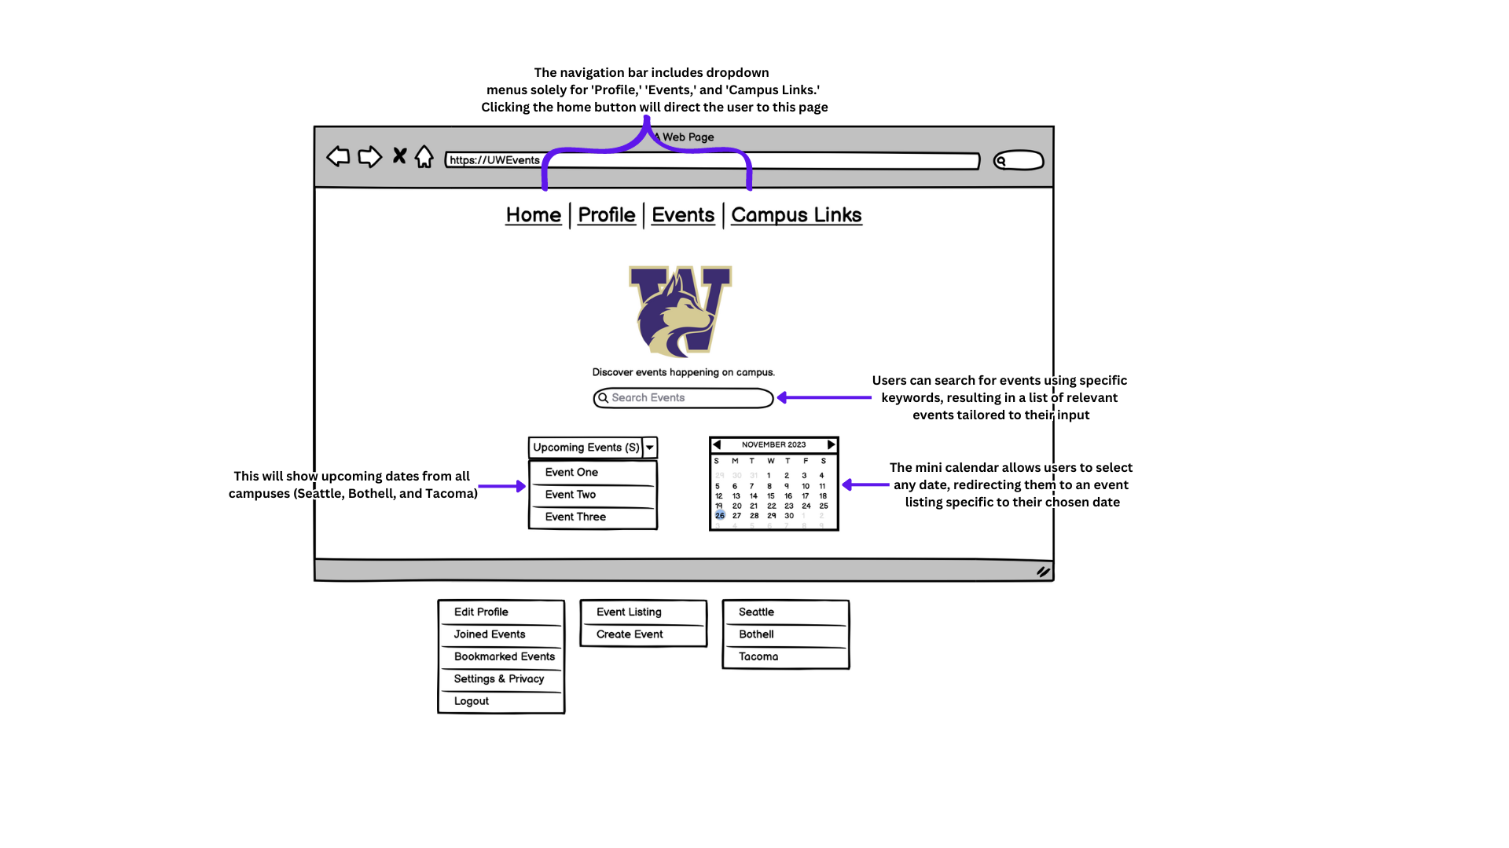

**Figure 1**

**Example of drop-down menu boxes:  
Left box:** Profile   
**Middlebox:** Events   
**Right box:** Campus Links & Upcoming Events (on the bottom left of the homepage)



**Figure 2**

**Event Listing (Annotations):**Selecting the ‘Events’ tab redirects users to the event listing page, displaying events from all UW campuses arranged chronologically by dates. On the right side, a small box provides key details about the selected event.

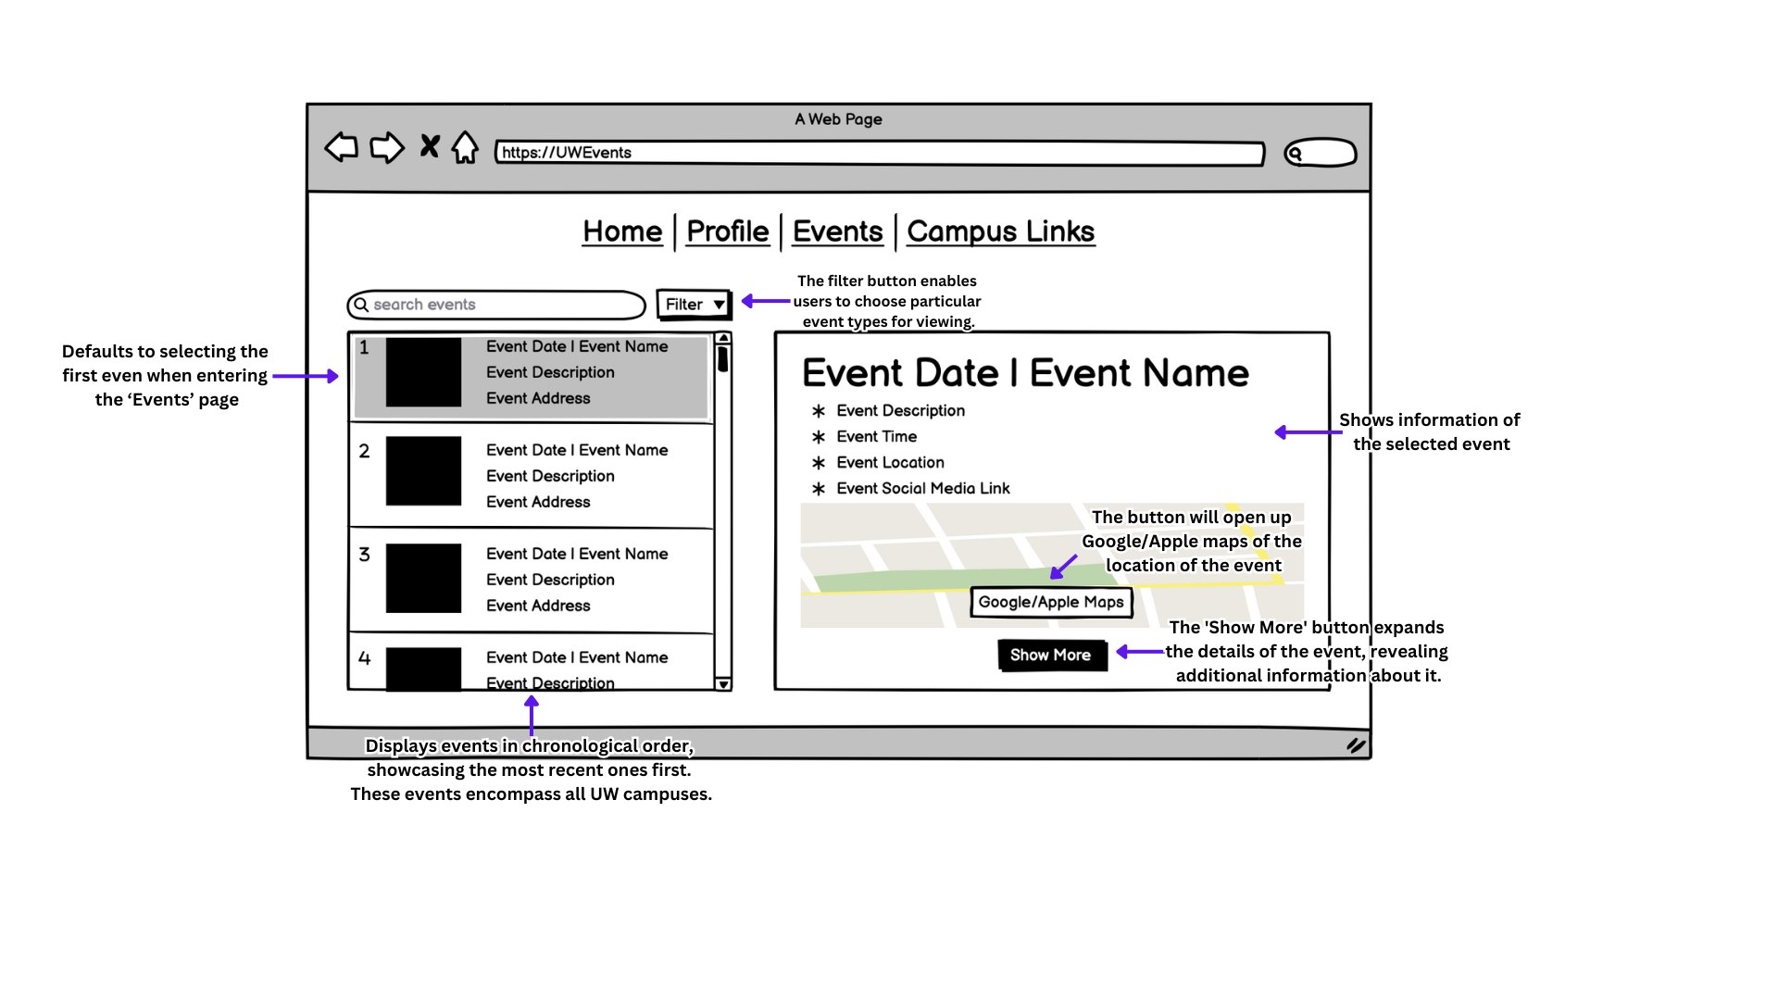

**Figure 3**

**Filter Option (Annotations):**Clicking the filter button will reveal a menu overlaying the current page, presenting various options for selection. Some options allow multiple selections, while others permit only one choice.

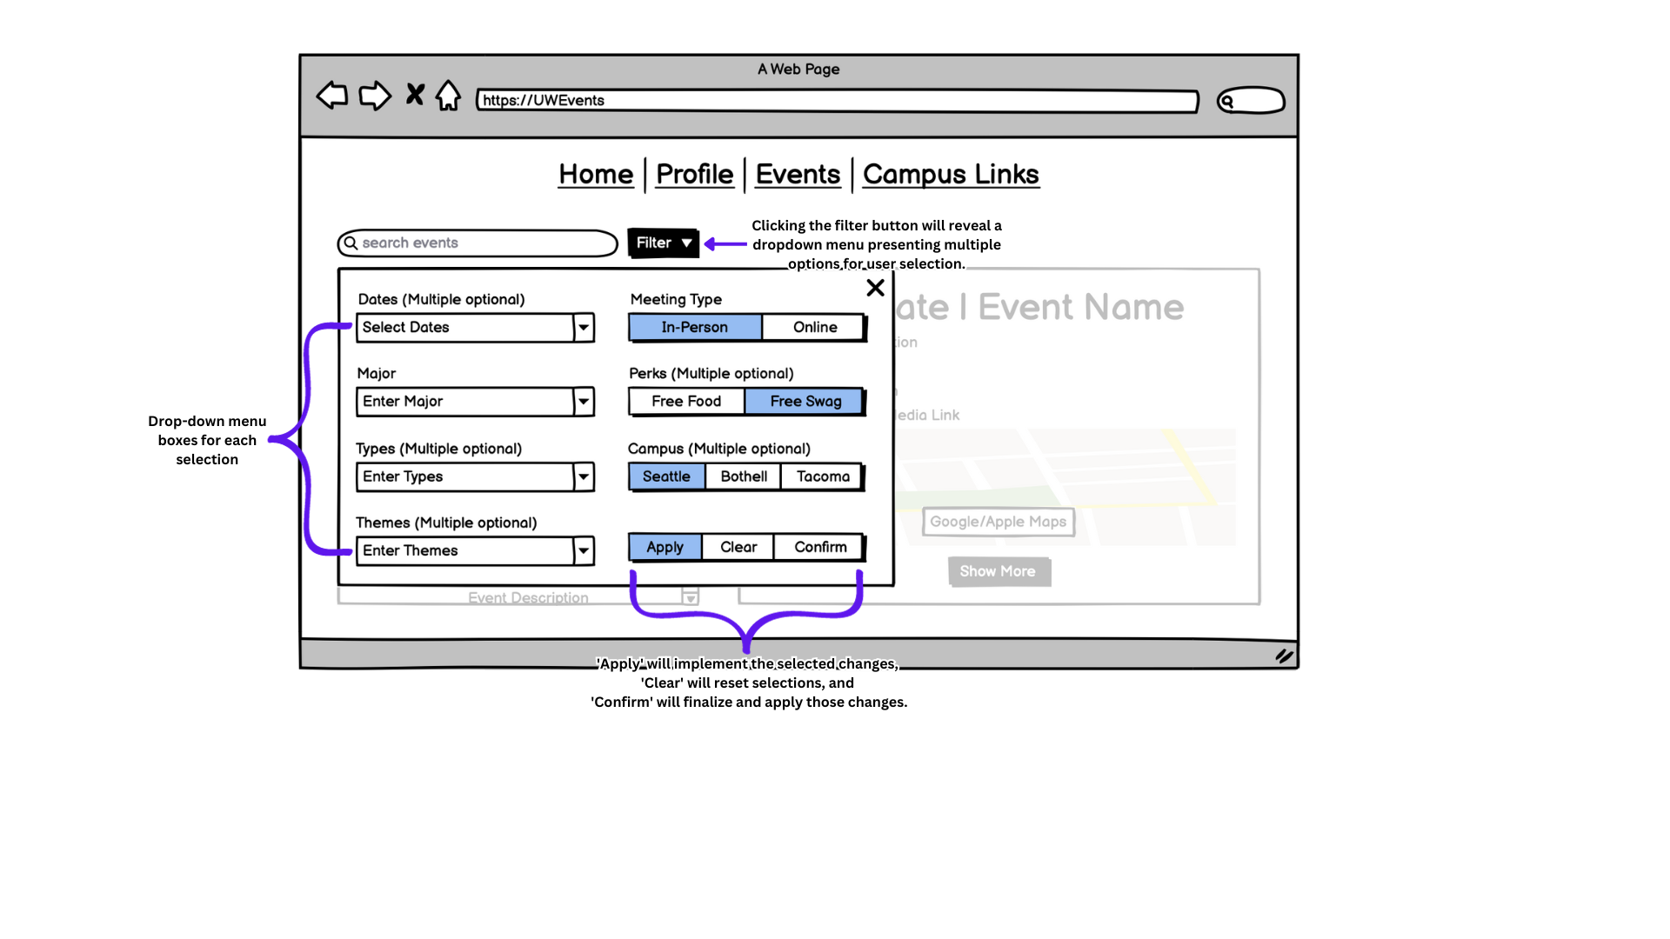

**Figure 4**

**Example of drop-down menu boxes:**  
**First box:** Dates (Multiple optional)  
**Second box:** Major  
**Third box:** Types (Multiple optional)  
**Fourth box:** Themes (Multiple optional)

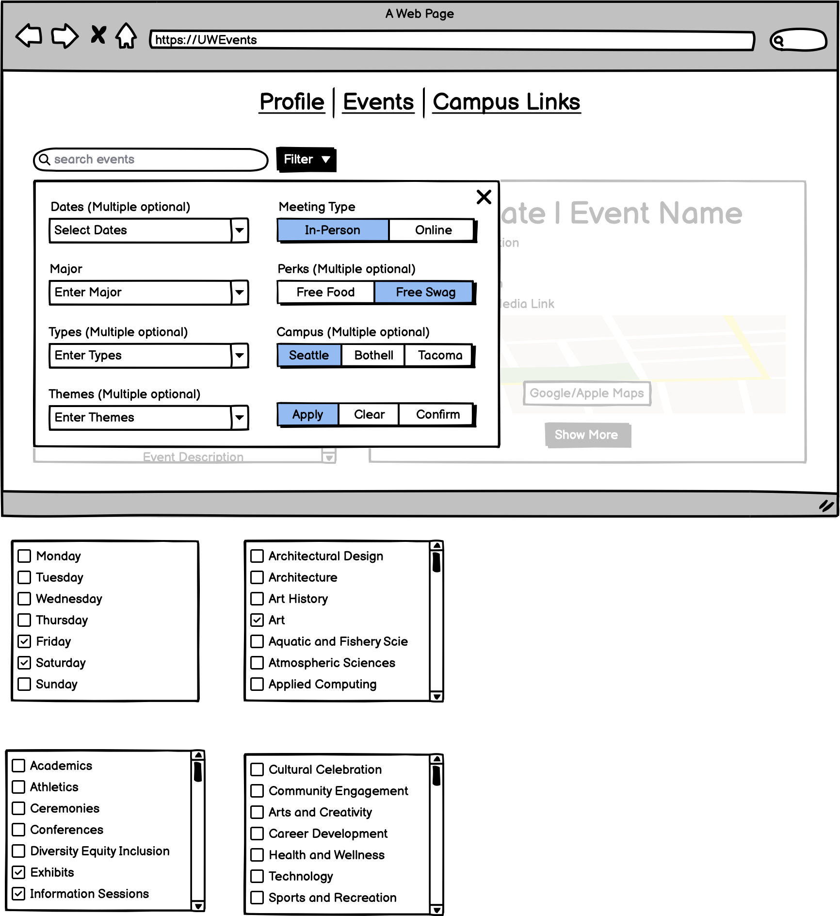 

**Figure 5**

**Filtered Event Listing (Annotations):**Upon selecting 'confirm,' the filter menu will vanish, leading to a screen refresh displaying specific events tailored to match the selected criteria. This refined list mirrors the event page scan filters, listing events chronologically by date.

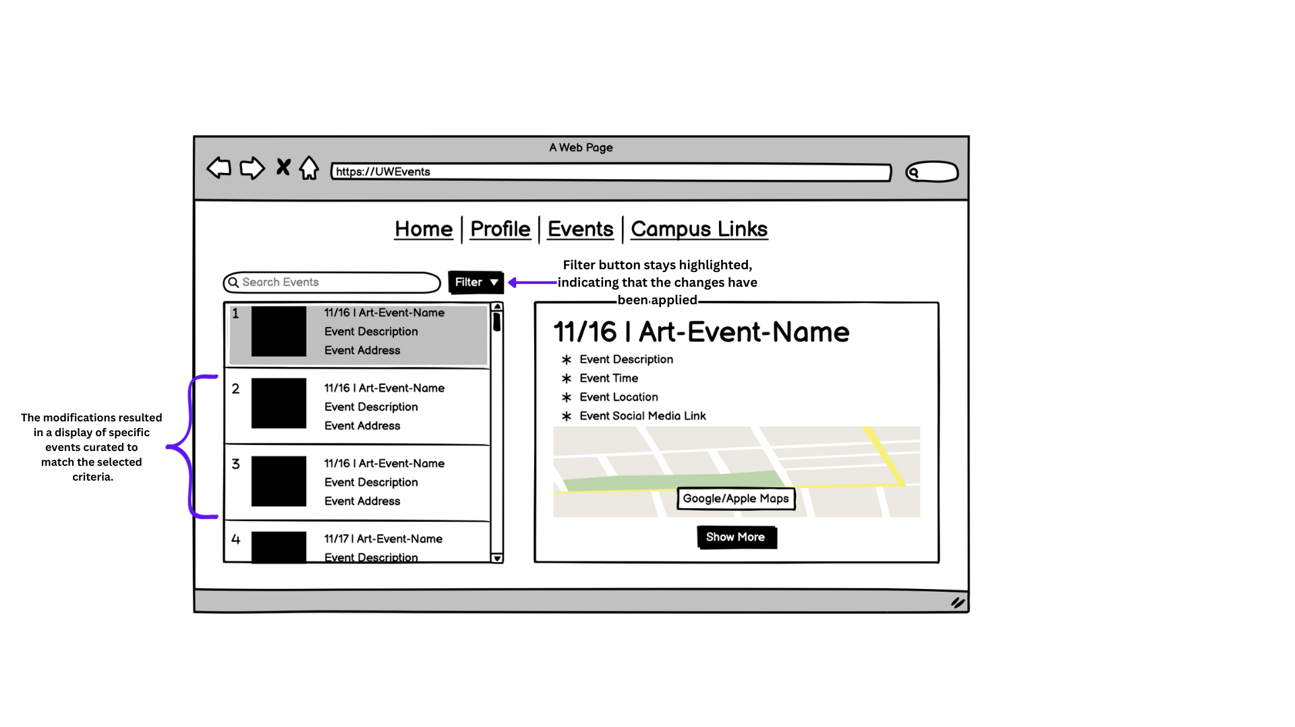

**Figure 6**

**Filtered Individual Event (Annotations):**When the user clicks the 'show more' button for their chosen event, it expands to reveal the individual event page. Here, more details and information about that event are displayed, and the user can choose to join or bookmark the event from this expanded view.

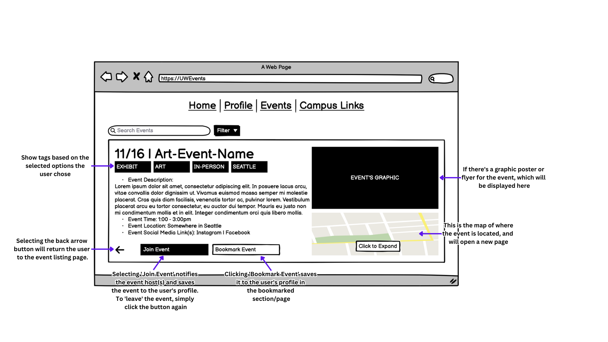

**Figure 7**

**User’s Profile (Annotation):**After joining the event, the user can navigate to their profile by selecting the ‘Profile’ tab from the navigation bar. On their profile page, their icon will be centered with their first and last name along with their UW email below it. Below these details, there will be five buttons that when clicked, will redirect them to specific pages on the current site.

* **My Events:** Displays events that the user has created.
* **Joined Events:** Lists events that the user has joined.
* **Bookmarked Events:** Shows events that the user has bookmarked.
* **Settings & Privacy:** Users can edit their profile details such as their name, UW email, and more.
* **Logout:** Logs the user out of the account.

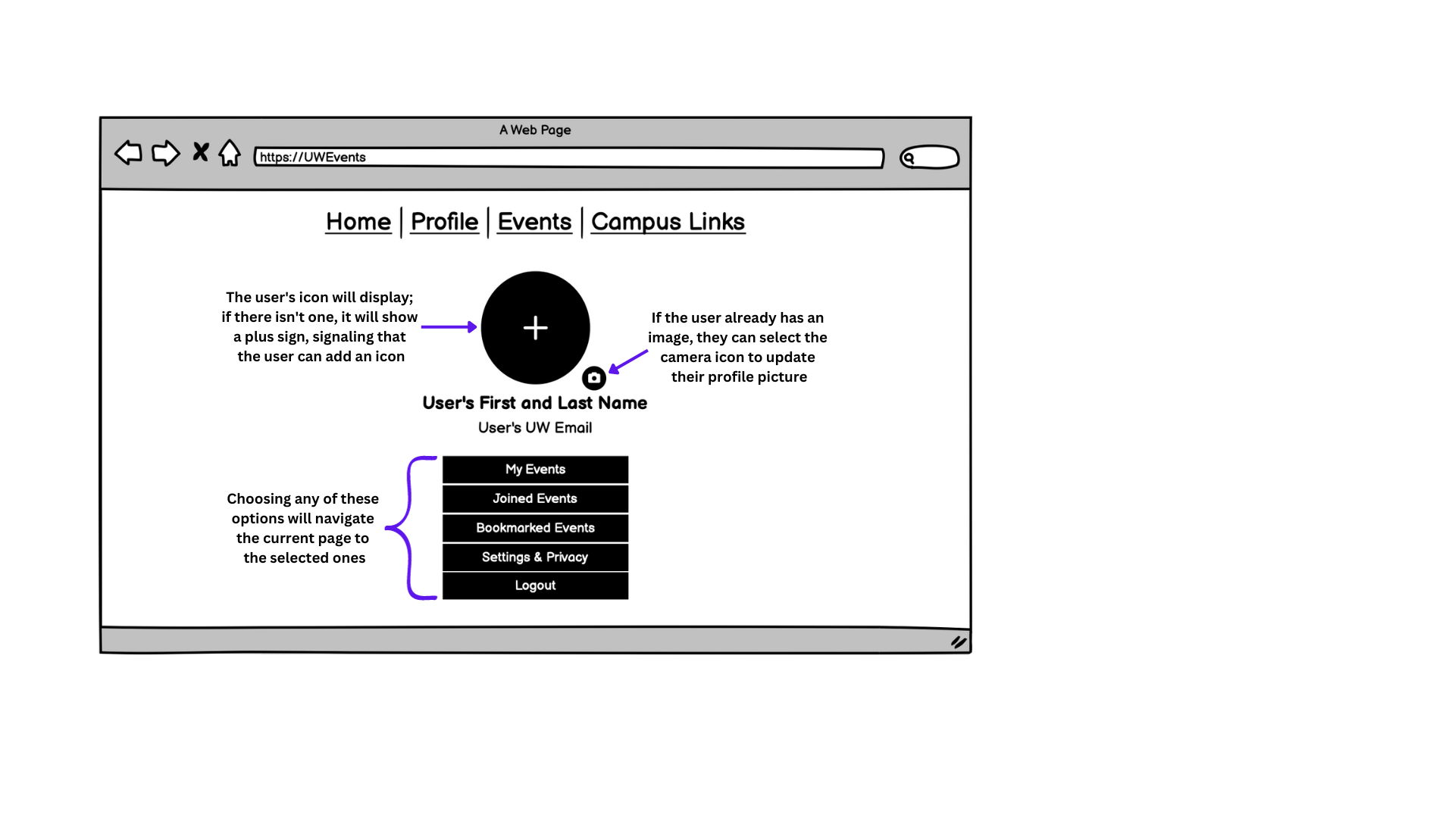

**Figure 8**

**Joined Events (Annotations):**After clicking the ‘Joined Events’ button, the user is redirected to a page similar to the event listing, showcasing only events they've joined. Additional features include a bell icon, enabling event notifications via text or email (highlighted when activated), and the 'leave event' button, allowing users to ‘leave’ the event and remove it from their ‘joined events’ list.

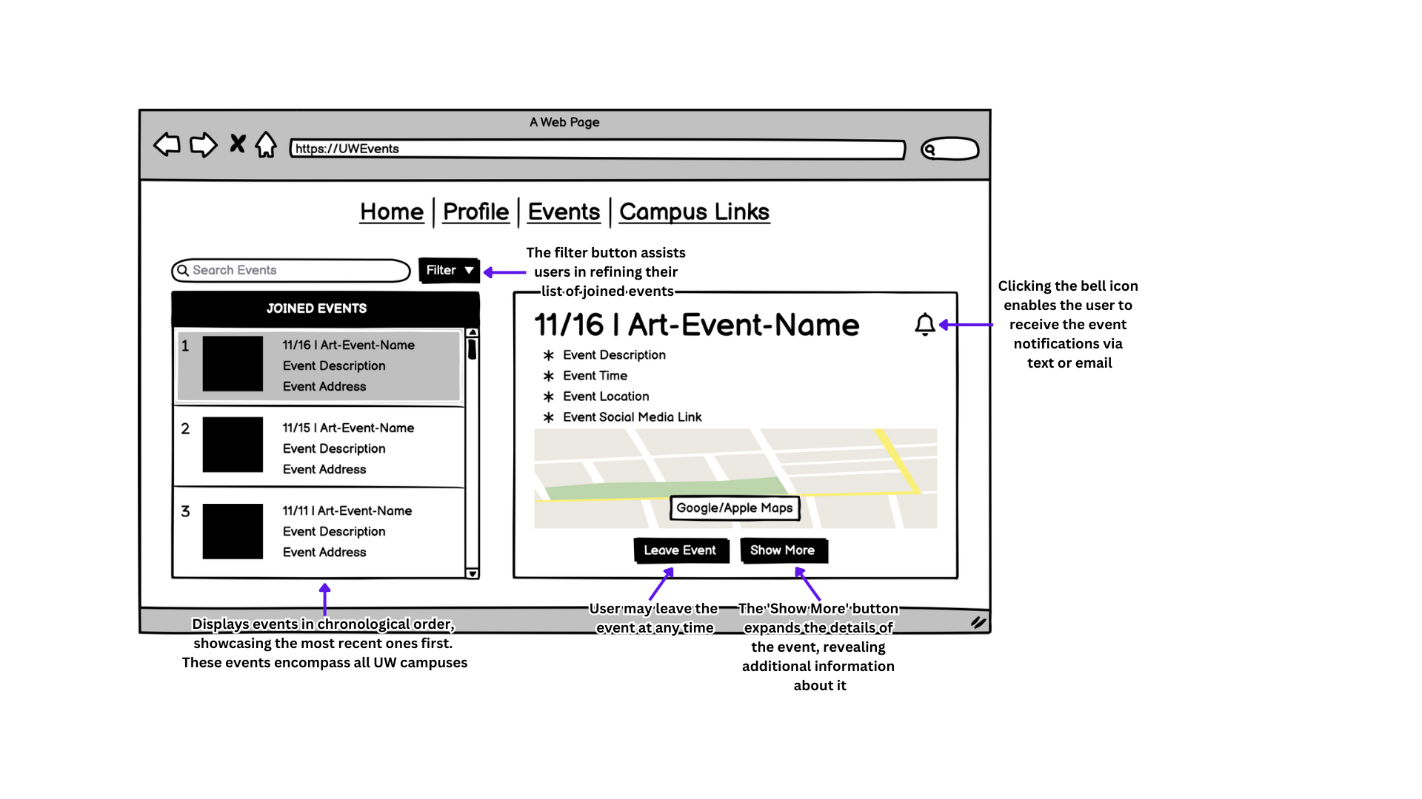

**Figure 9**

# 

# Moodboard

Directly from the UW website explaining the color choice, purple brings passion and gold represents excellence. These colors, with a secondary palette of black, grey, and white, create the palette of the produced prototype. The fonts: Encode Sans, Uni Sans, and Open Sans, are used both on the official UW website and the newly designed UW Events website prototype.

# 

**Figure 10**

# Design Language / Style Guide

## Font

**Selected Fonts:**

* Encode Sans
* Uni Sans
* Open Sans

**Reason:**

Choosing these fonts consistent with the University of Washington (UW) for this website which is focused on creating and joining events at UW is a strategic decision with several advantages:

* **Branding and Identity:** Fonts play a pivotal role in visual branding. By utilizing fonts similar to those used in UW's official communications, the website establishes a cohesive visual identity. Consistency in typography creates a seamless connection, reinforcing the message that the website is an important part of the UW ecosystem.
* **Familiarity and Recognition:** Consistent typography creates familiarity. Users acquainted with UW's communications, whether through official websites, publications, or branding materials, will instantly recognize and associate the chosen fonts with the university. This recognition fosters trust and reliability, making users feel more at ease when engaging with the event platform.
* **Consistency and Professionalism:** Like maintaining consistent colors, aligning with UW's fonts maintains a professional appearance. It reflects a commitment to upholding UW's visual standards across various platforms. A coherent typographic style across official university channels and the event platform signifies attention to detail and professionalism.

**Link to fonts:**

* <https://www.washington.edu/brand/graphic-elements/font-download/>

## 

## Colors

**Selected Colors:**

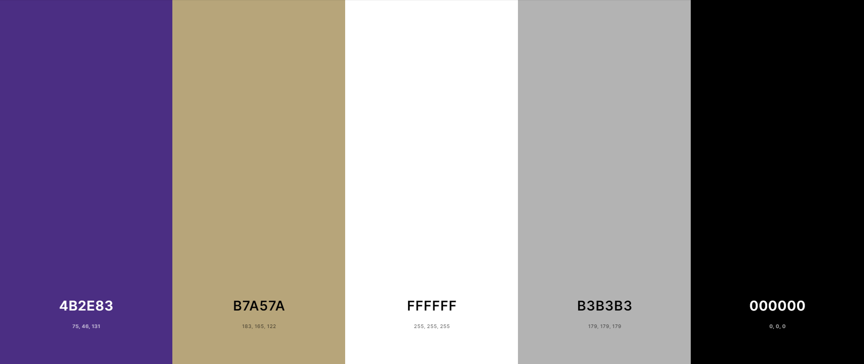

**Figure 11**

* **Purple:** #4B2E83
* **Gold:** #B7A57A
* **Grey:** #B3B3B3
* **Black:** #000000

**Reason:**

Choosing these colors consistent with the University of Washington (UW) for this website which is focused on creating and joining events at UW is a strategic decision with several advantages:

* **Branding and Identity:** Using UW's official colors helps in establishing a visual connection with the university. It communicates to users that the website is associated with UW, reinforcing a sense of trust and credibility.
* **Familiarity and Recognition:** People familiar with UW's branding will easily recognize and associate the website with the university. This familiarity can create a sense of comfort and reliability, encouraging users to engage more readily with the platform.
* **Consistency and Professionalism:** Consistency in colors across various platforms, including official university websites, can enhance the professional appearance of the event platform. It reflects a commitment to maintaining UW's visual standards and professionalism.

# High-Fidelity Wireframes

## Navigation Bar:

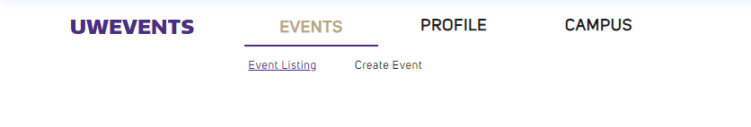

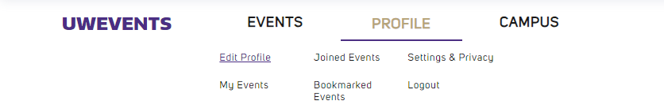

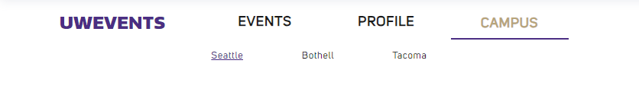

**Figure 12**

The navigation bar comprises three distinct tabs: 'Events,' 'Profile,' and 'Campus,' each serving specific purposes:

* **Events:** This section contains links to 'Event Listing,' enabling users to browse through various events hosted across different UW campuses. The 'Create Event' tab allows users to craft and submit their events to UWEvents. Upon approval, these events are included in the Event Listing for broader visibility.
* **Profile:** Users find access to 'Edit Profile' for personal profile adjustments, 'Joined Events' to view the events they've committed to attending, and 'Bookmarked Events' for a collection of events they've shown interest in but haven't joined yet. 'Settings & Privacy' offers options to modify profile settings such as student email and privacy preferences. Finally, the 'Logout' link enables the user to log out of their account.
* **Campus:** These links directly redirect users to the respective homepages of each UW campus website for convenient access to campus-specific information and resources.

## Landing Page:

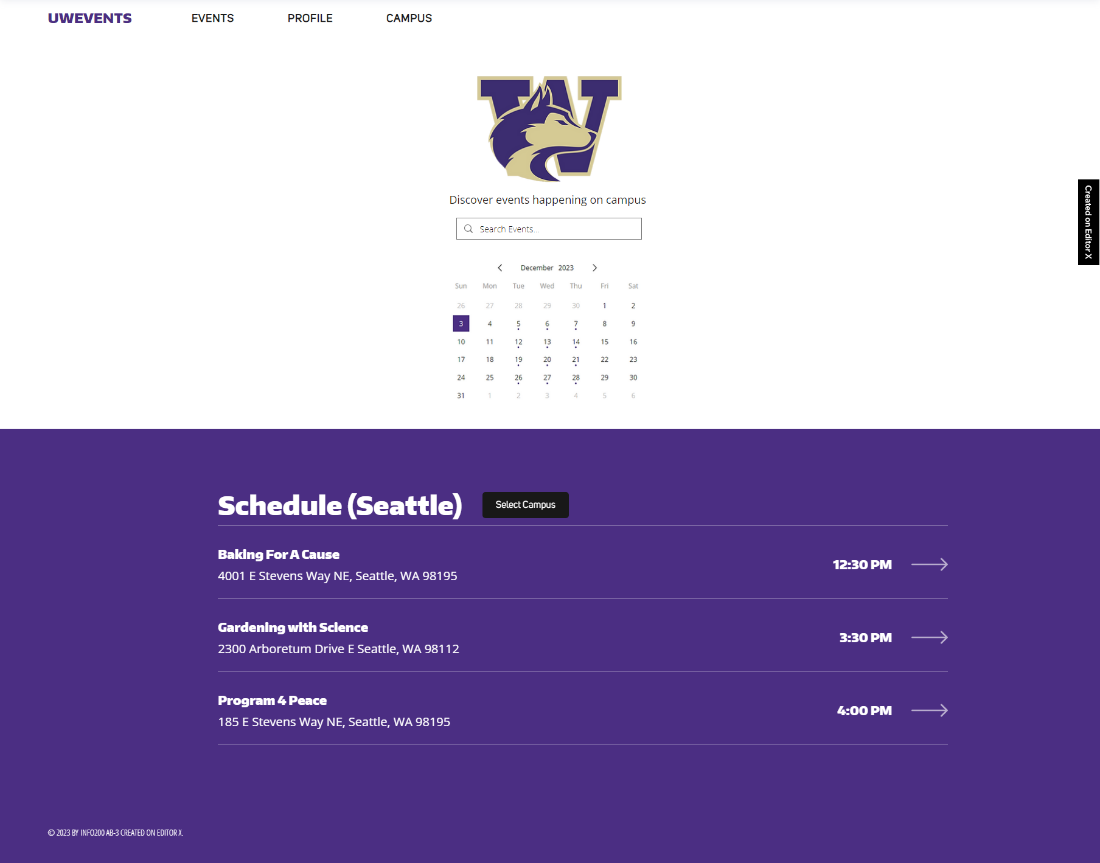

**Figure 13**

Upon entering the UWEvents website, users are greeted by the UW Husky logo and a tagline, below it, there is a a central search bar facilitating event discovery through keyword searches. Upon entering their query, the site redirects them to a tailored listing page displaying events related to or resembling the search terms. Adjacent to the search bar lies a concise calendar, allowing users to select specific dates and explore events scheduled for those days. Further down, a divider showcases the daily event schedule for the chosen campus, spotlighting the top three events sorted by their respective timings. Users can easily navigate to these events by clicking, seamlessly redirecting to individual event pages for more details.

## 

## Event Listing Page:

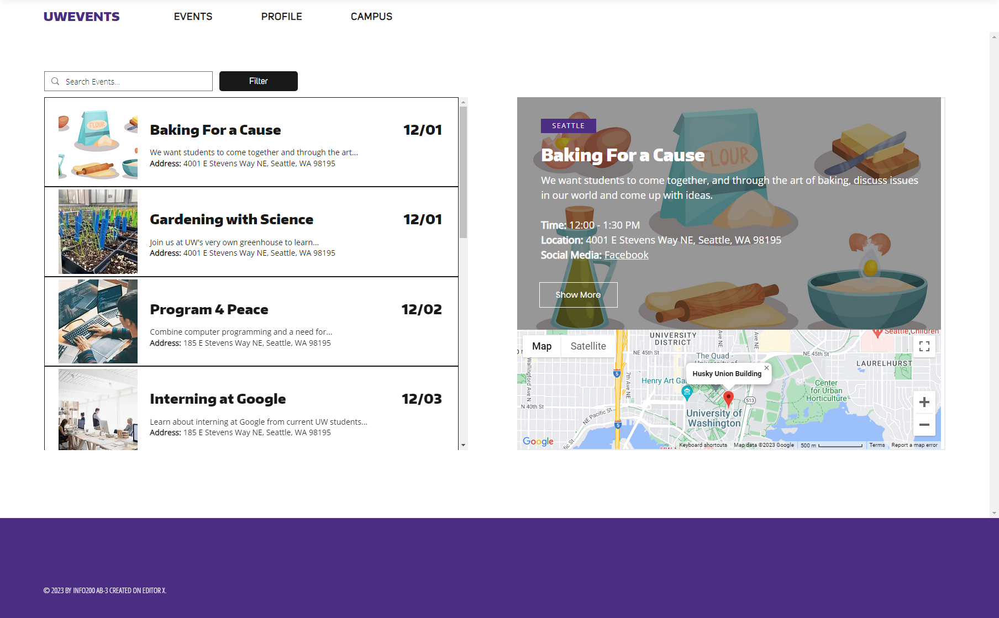

**Figure 14**

When users select 'Event Listing' from the Events tab, they encounter a variety of events displayed in a well-organized manner. On the left-hand side, the events are listed chronologically from the present date onwards. Meanwhile, on the right, detailed information about the selected event from the left panel is presented. This includes important details like the event's campus affiliation, title, concise description, timing, location, and any associated social media links. For users seeking more information, a dedicated button offers direct access to the individual event page.

Additionally, each event box is accompanied by a map (Apple/Google), pinpointing the exact location of the event, and offering users a visual reference to the venue.

## 

## Event Listing Page + Filter:

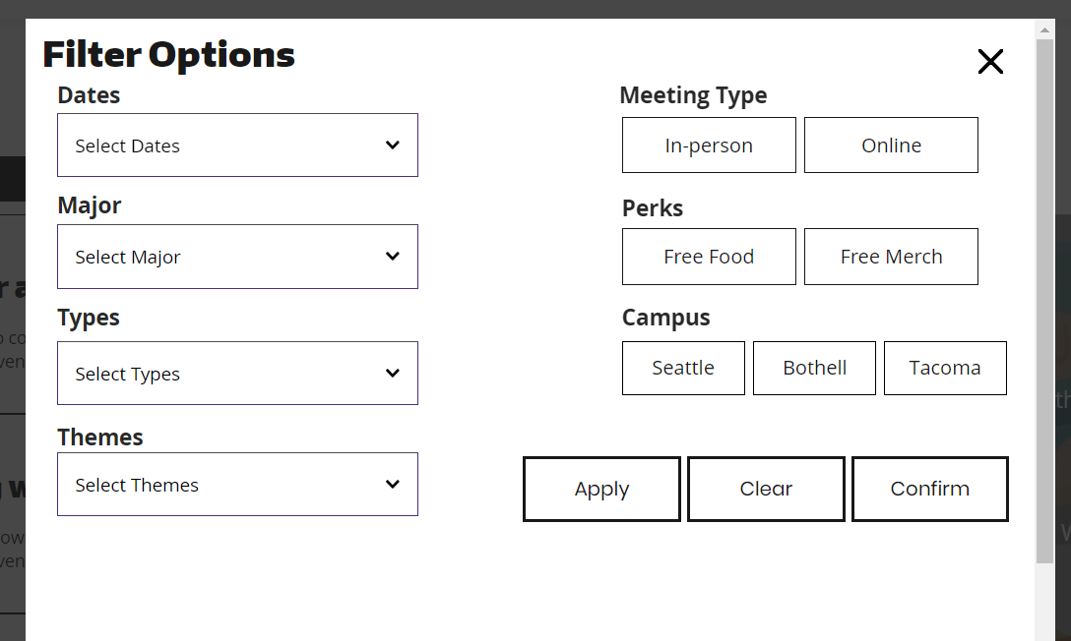

**Figure 15**

Displays the filter pop-up box. Allows the user to select characteristics to narrow down toward a specific search. Each filter has multiple options to ensure that the user can discover events.

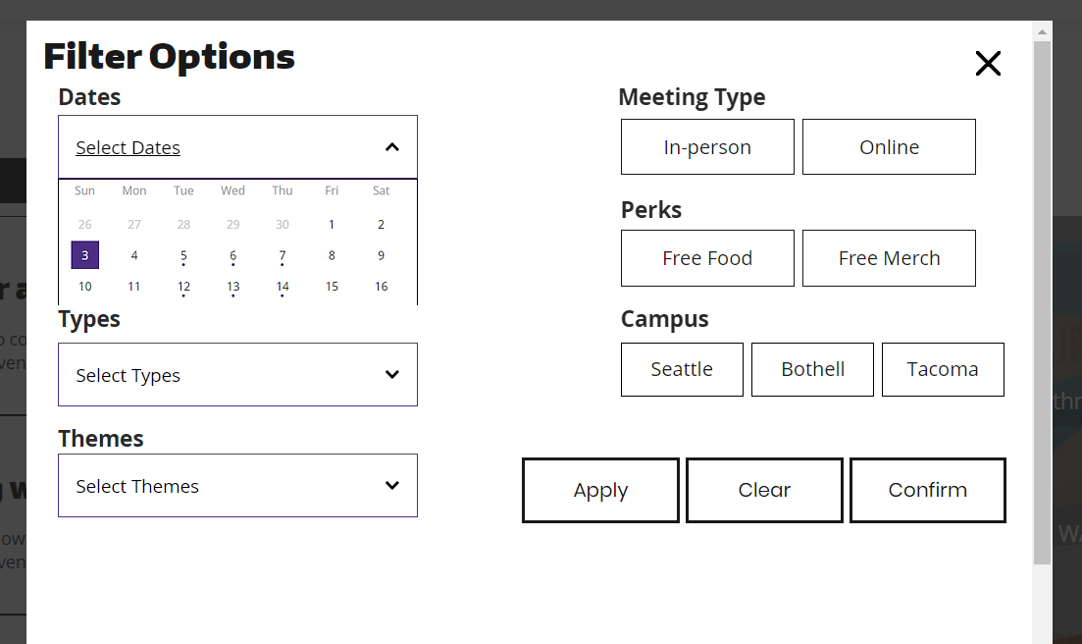

**Figure 16**

The image above depicts the “Select Dates” option. A calendar is shown to select which dates the user prefers in search of events.

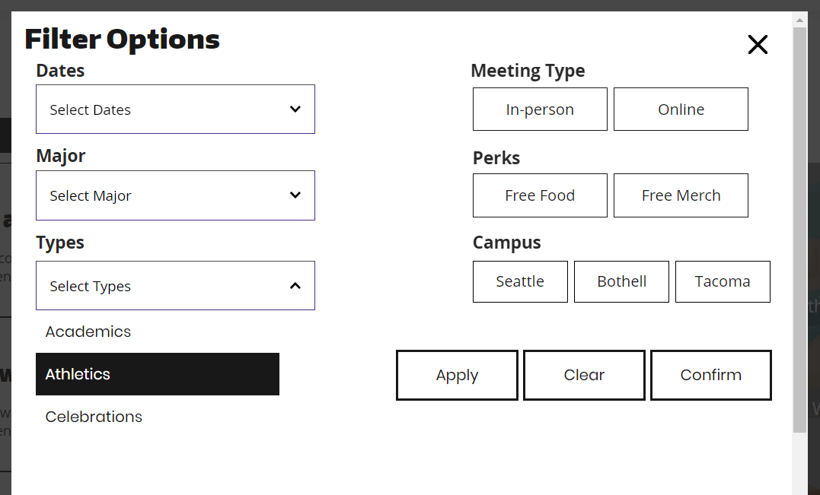

**Figure 17**

Above is the selection of an event that falls under the “Athletics” type. The same selection process is used for “Major” and “Theme” selections.

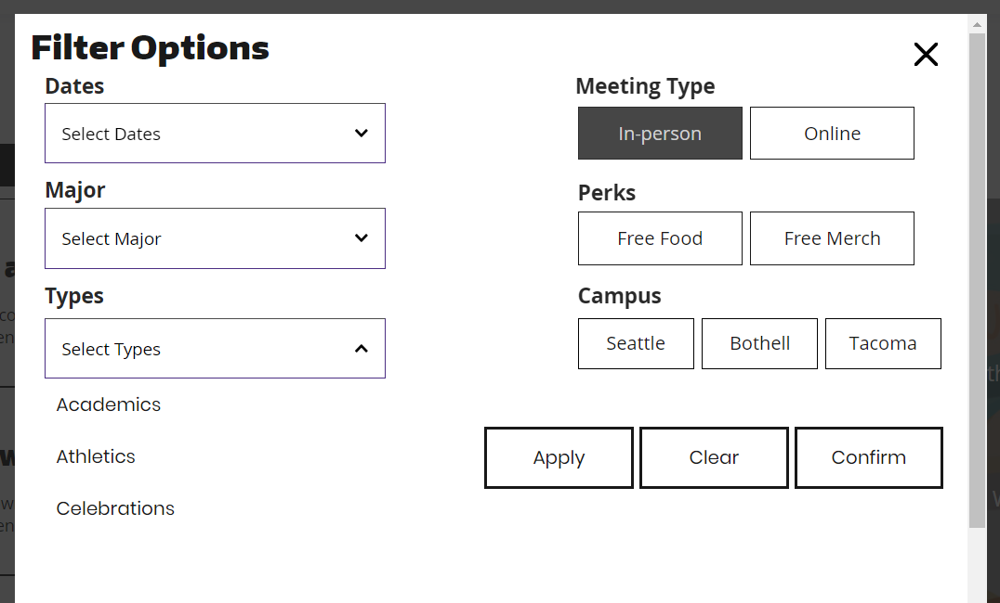

**Figure 18**

The type of meeting can also be selected with “In-person” and/or “Online” selection. This is the same for “Perks” and “Campus” filter selections.

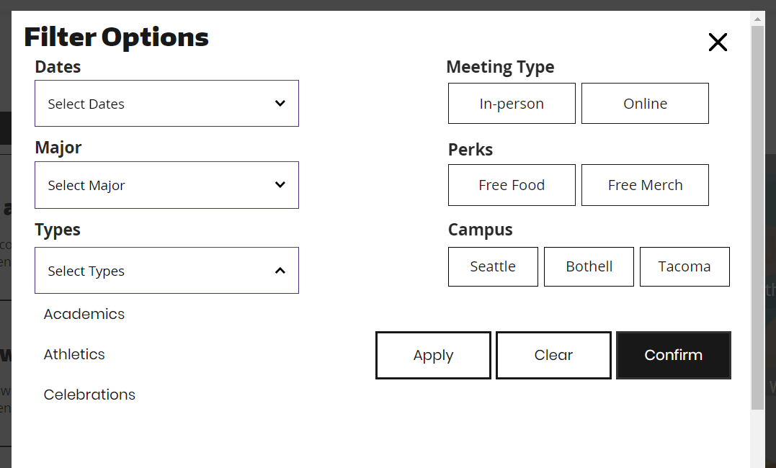

**Figure 19**

Three options impact all of the filter options: Apply, Clear, and Confirm. Apply is used to activate the selected filters. Clear resets the selections and allows the user to start the process over. Finally, Confirm verifies that all choices have been processed and inputted toward the “Event Listings” page.

## 

## Individual Event Page:

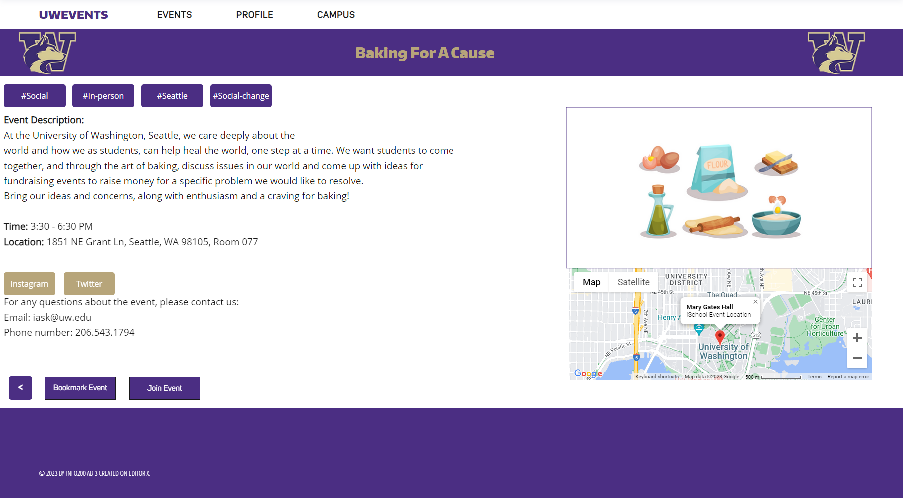

**Figure 20**

When accessing the individual event page, users encounter a wealth of detailed information about the event. This includes an expanded description, tags indicating the event's different categories (similar to hashtags), and relevant social media links.

Users have the option to join or bookmark the event, directing it to the respective pages based on their selection for future reference. In case of disinterest, a back button seamlessly returns users to the event listing page, exactly where they were exploring before entering the individual event page.

## Create Event Page:

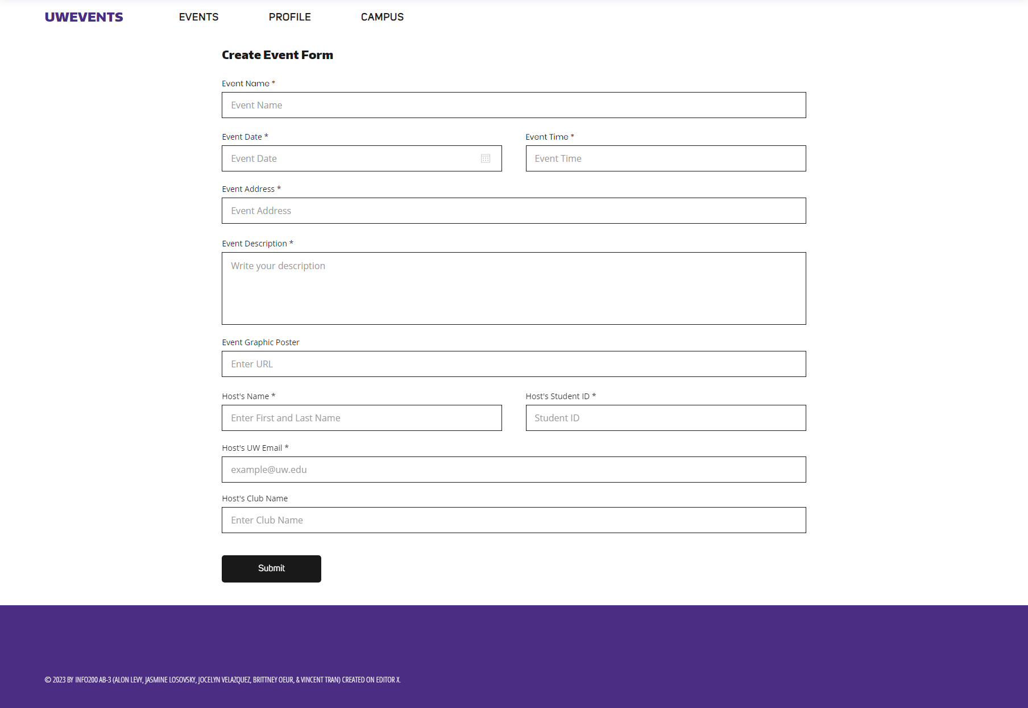

**Figure 21**

Upon entering the 'Create Event' page, the user will be prompted to complete a form to submit their event. Following submission, they must await approval. Once the event receives approval, it will become visible on the 'Event Listing' page and will be stored within their 'My Events' section.

## User Page:

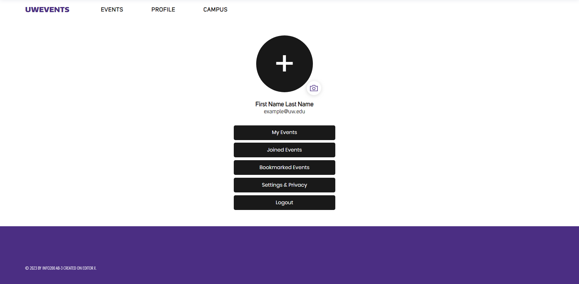

**Figure 22**

After hovering the mouse over ‘Profile’ and selecting ‘Edit Profile’, the user will encounter a page displaying information about themselves. This page shows the information that may be displayed to others, such as a profile picture, name, and UW email. The page also has buttons that take the user to their pages, including ‘My Events’, ‘Joined Events’, and ‘Bookmarked Events’. As well as a button leading the user to the ‘Settings & Privacy’ page and a ‘Logout’ button. If the user has no profile picture a plus icon will appear in the circle. This can be pressed to add one. If the user does have a profile picture they can press on the camera icon to change it.

## 

## My Events Page:

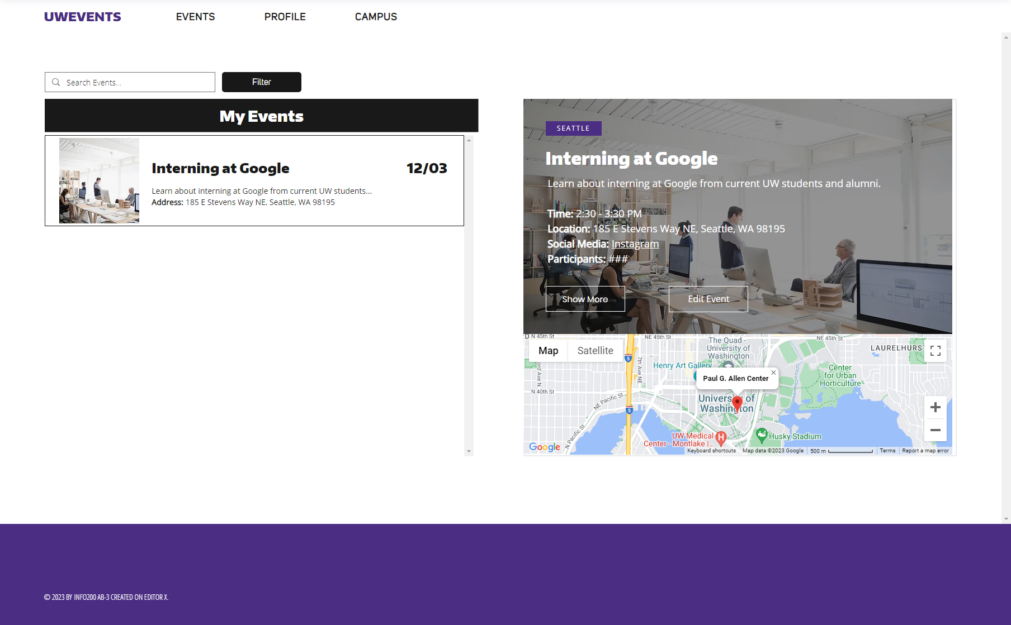

**Figure 23**

When users access the 'My Events' page within the 'Profile' tab, they encounter a layout reminiscent of the familiar 'Event Listing' page, showcasing exclusively the events created by the user. Here, users possess the ability to refine their event details by simply clicking the 'Edit Event' button. However, any changes submitted necessitate approval before being officially implemented on the UWEvents website.

Once approved, the system promptly notifies participants via email or text about the approved changes, ensuring seamless communication and transparency regarding event alterations. Additionally, this section provides insights into the number of participants committed to joining each event, offering a clear overview of attendee engagement.

## 

## Joined Events Page:

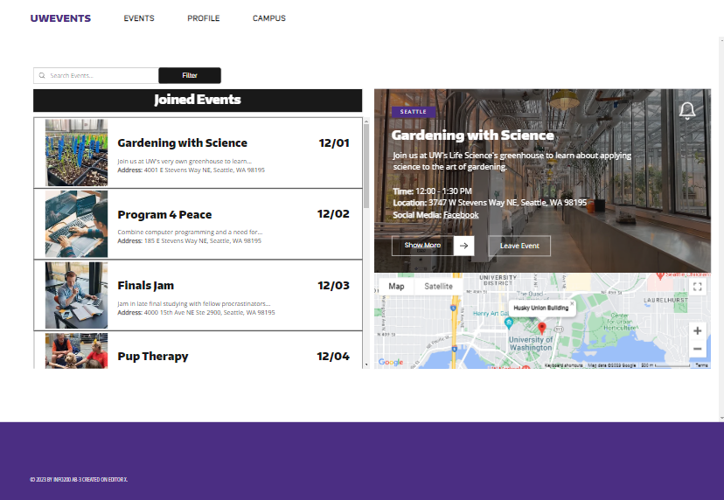

**Figure 24 *(Greenhouse image utilized (Schlosser, 2022)***

After clicking the ‘Joined Events’ button, the user is redirected to a page chronologically listing only events they've joined. Additional features include a bell icon in the top right to enable event notifications (via text or email) and the 'leave event' button, allowing users to ‘leave’ the event and remove it from their ‘joined events’ list.

## Bookmarked Events Page:

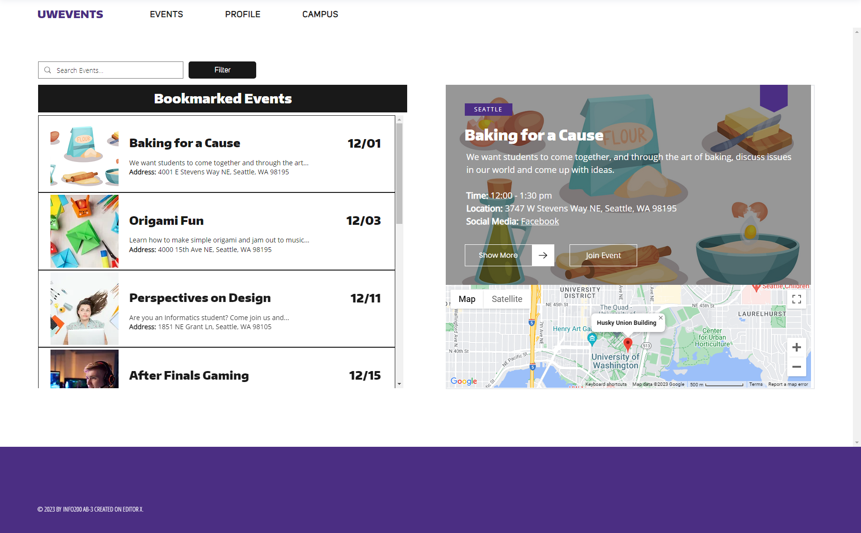

**Figure 25**

When users navigate to 'Bookmarked Events' within the Profile tab, they'll discover a dedicated page akin to the 'Event Listing' page. However, this page exclusively showcases events saved by the user. It serves as a collection of events that are related to the user's interest, offering a convenient place to consider attendance.

Displayed on the right-hand side of each event box is a distinct bookmark icon placed in the top right corner, resembling physical bookmarks found in books. This visual indicator denotes events that the user has bookmarked. By clicking this icon, users can effortlessly remove the event from their bookmarked list.

Moreover, there's a convenient button provided for users who may have reconsidered their interest and now wish to attend the event. Upon clicking this button to join, the event will be moved to their 'Joined Event' page, creating seamless access and organization of events they've committed to attending.

# Interactive Prototype

* **Website:**
  + The group used ‘Editor X’ to create the interactive prototype.
  + **EditorX Link for UWEvents:** <https://britoeur.editorx.io/uwevents>
    - **Screen dimensions:** 1920 x 1080 pixels
    - The sole functional interactive event is 'Baking For A Cause.' Upon selecting 'Show More,' users gain access to the dedicated individual event page for this specific event.
  + **EditorX Link:** <https://www.editorx.com/>

# 

# References

Art. (n.d.). *Reddit - Dive into anything*. <https://www.reddit.com/r/udub/comments/791e5s/unofficial_improved_uw_rso_directory/?onetap_auto=true>

*Balsamiq. Rapid, effective and fun wireframing software | Balsamiq*. (n.d.). <https://balsamiq.com/>

Cakir, A. (2023, October 27). *User Persona template and Examples | Xtensio*. Xtensio. <https://xtensio.com/user-persona-template/>

*Canva*. (n.d.). Canva. <https://www.canva.com/>

*Canvas Login*. (n.d.). <https://canvas.uw.edu/>

*Colors*. (n.d.). UW Brand. <https://www.washington.edu/brand/graphic-elements/primary-color-palette/>

*Events | Handshake*. (n.d.). Handshake. <https://uw.joinhandshake.com/stu/events?collection=ALL&eventFormat=HYBRID&sort=RELEVANCE&date=ALL>

*Google*. (n.d.). <https://www.google.com/>

*Groups and activities*. (n.d.). Student Life. <https://www.washington.edu/studentlife/groups-activities/>

How to conduct user interviews. (2023, December 12). *The Interaction Design Foundation*. <https://www.interaction-design.org/literature/article/how-to-conduct-user-interviews>

*Maps and campus history*. (n.d.). UW Sustainability. <https://sustainability.uw.edu/maps/>

*Registered Student Organizations UW (RSOS)*. (n.d.). Huskylink. <https://huskylink.washington.edu/>

Roscoe, J. (2022, September 20). *Opinion: Handshake is not letting NYU students shake any hands - Washington Square News*. Washington Square News. <https://nyunews.com/opinion/2022/09/20/nyu-students-should-abandon-handshake/>

Schlosser, K. (2022, October 28). Inside the Univ. of Washington’s new greenhouse, where a tech upgrade keeps the 6,000 plants happy. *GeekWire*. <https://www.geekwire.com/2022/inside-the-univ-of-washingtons-new-greenhouse-where-a-tech-upgrade-keeps-the-6000-plants-happy/>

*Typography*. (n.d.). UW Brand. <https://www.washington.edu/brand/graphic-elements/font-download/>

*UW Campus Map*. (n.d.). Campus Maps. <https://www.washington.edu/maps/#>

*Uw Events - Google Search*. (n.d.). <https://rb.gy/nvbc5>

# Appendix

* **UW Husky Logo**



* **UW Colors Link:**
  + <https://www.washington.edu/brand/graphic-elements/primary-color-palette/>
* **Calendar:**
  + There was no option to import an embedded calendar in EditorX
  + 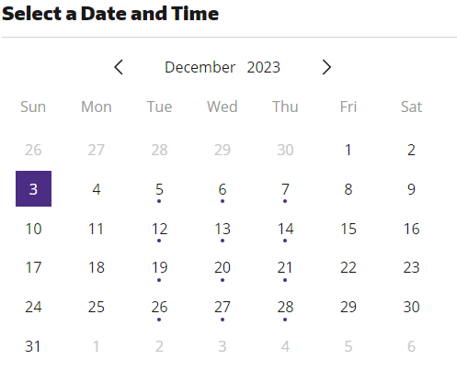
* **Interview Notes**
  + User Interview 2 Notes:
    - Cross-campus student (Bothell and Seattle)
    - Challenging for cross-campus students to find building names and numbers. (They are different from each campus).
    - Appealing graphic design flyers is a plus
    - Social media is often used to announce different events at UW. Each club typically has its social media.
    - The user appreciates knowing if the event offers incentives (such as free food or something free merch).
    - Messy organization of event information is time-consuming and confusing
    - Find event information online.
    - Gain event knowledge through flyers, word-by-mouth, social media, email, and UW's main website.
* **Survey Results:**
  + <https://docs.google.com/forms/d/1PlgLWvOJGXxmQlMmiSXmPT2JypvKZ0umnHe3fAApKp8/edit#responses>
* **Canvas Calendar (wireframe inspiration):**

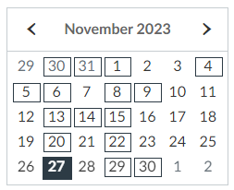

* **Gmail icon (wireframe inspiration):**

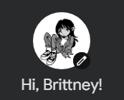

* **Google Search Bar (wireframe inspiration):**

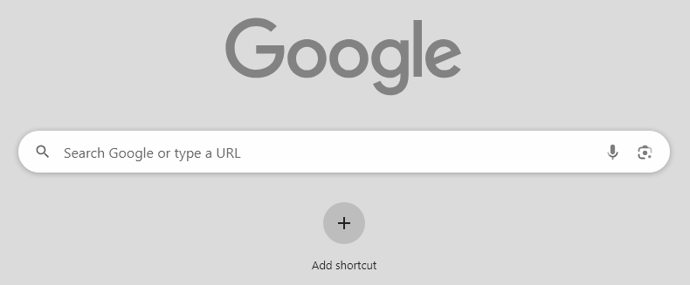

* **Huskylink (RSOs) Home Page (wireframe inspiration):**

